TryHackMe Writeup 04 — Windows Basics
Internship: DG Interns Hub — Week 2
Platform: TryHackMe
Room: Windows Basics
Evidence: Windows_Basics.png

1. Objective
Understand foundational Windows operating system concepts relevant to system administration and Security Operations Centre (SOC) investigations.

2. Overview
Windows uses processes, services, user accounts, groups, permissions and system settings to run applications and manage access. Security analysts examine these components when investigating unusual behaviour.

3. Key Concepts
Concept | What it means
Processes | Running instances of programs; inspect unexpected or resource-intensive processes.
Services | Background components that may start automatically or on demand.
Users and groups | Accounts and group membership determine access and administrative privileges.
UAC | User Account Control prompts before actions requiring elevated permissions.
Registry | Hierarchical database storing operating-system and application configuration.
Event Viewer | Windows logs used to investigate application, system and security activity.

4. Security Monitoring Relevance
- Security log: investigate successful and failed sign-ins, account creation and privilege changes.
- System log: inspect service installation and system-level events.
- Application log: investigate application crashes and errors.
- Review administrator group changes and unfamiliar services as potential investigation leads.

5. Connection to My Week 2 Lab
In a separate Windows 11 virtual-machine exercise, I used Event Viewer to examine event IDs 4624, 4625, 4720, 4732, 7045 and 1102. I also used PowerShell to retrieve failed sign-in records and export them to CSV. These lab activities reinforce Windows logging concepts; they are not presented as steps performed inside the TryHackMe room.

6. Evidence
TryHackMe room completion screenshot: Windows_Basics.png
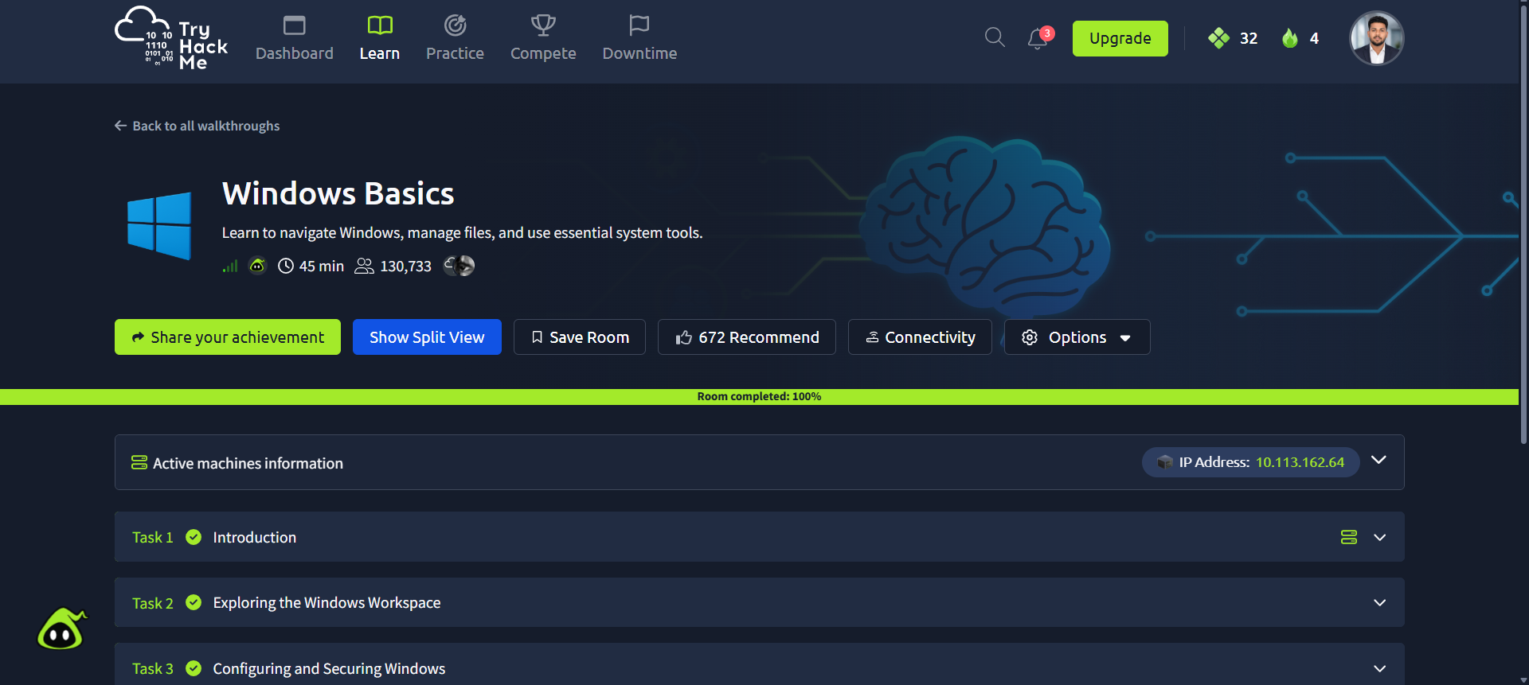

7. Conclusion
This room introduced Windows fundamentals that support endpoint investigation and event-log analysis. Knowing normal Windows components helps an analyst identify unusual changes and investigate them using supporting evidence.

